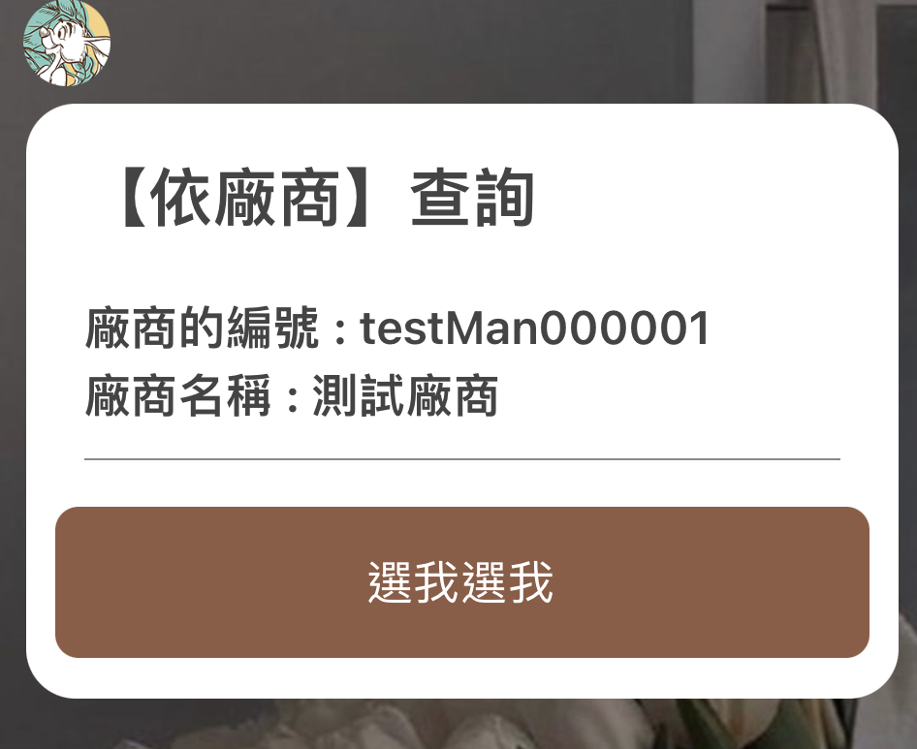

{

"type": "bubble",

"body": {

"type": "box",

"layout": "vertical",

"spacing": "xxl",

"contents": [

{

"type": "text",

"text": "【商品查詢1】查詢",

"size": "xl",

"weight": "bold"

},

{

"type": "box",

"layout": "vertical",

"spacing": "sm",

"contents": [

{

"type": "box",

"layout": "vertical",

"contents": [

{

"type": "text",

"text": "廠商的編號：",

"weight": "bold",

"margin": "sm",

"flex": 0

},

{

"type": "text",

"text": "廠商的名稱：",

"flex": 0,

"margin": "sm",

"weight": "bold"

}

]

}

]

},

{

"type": "separator",

"margin": "lg",

"color": "#888888"

}

]

},

"footer": {

"type": "box",

"layout": "vertical",

"contents": [

{

"type": "button",

"style": "primary",

"color": "#A0522D",

"margin": "none",

"action": {

"type": "message",

"label": "選擇此廠商",

"text": "選擇廠商"

},

"height": "md",

"offsetEnd": "none",

"offsetBottom": "sm"

}

],

"spacing": "none",

"margin": "none"

}

}